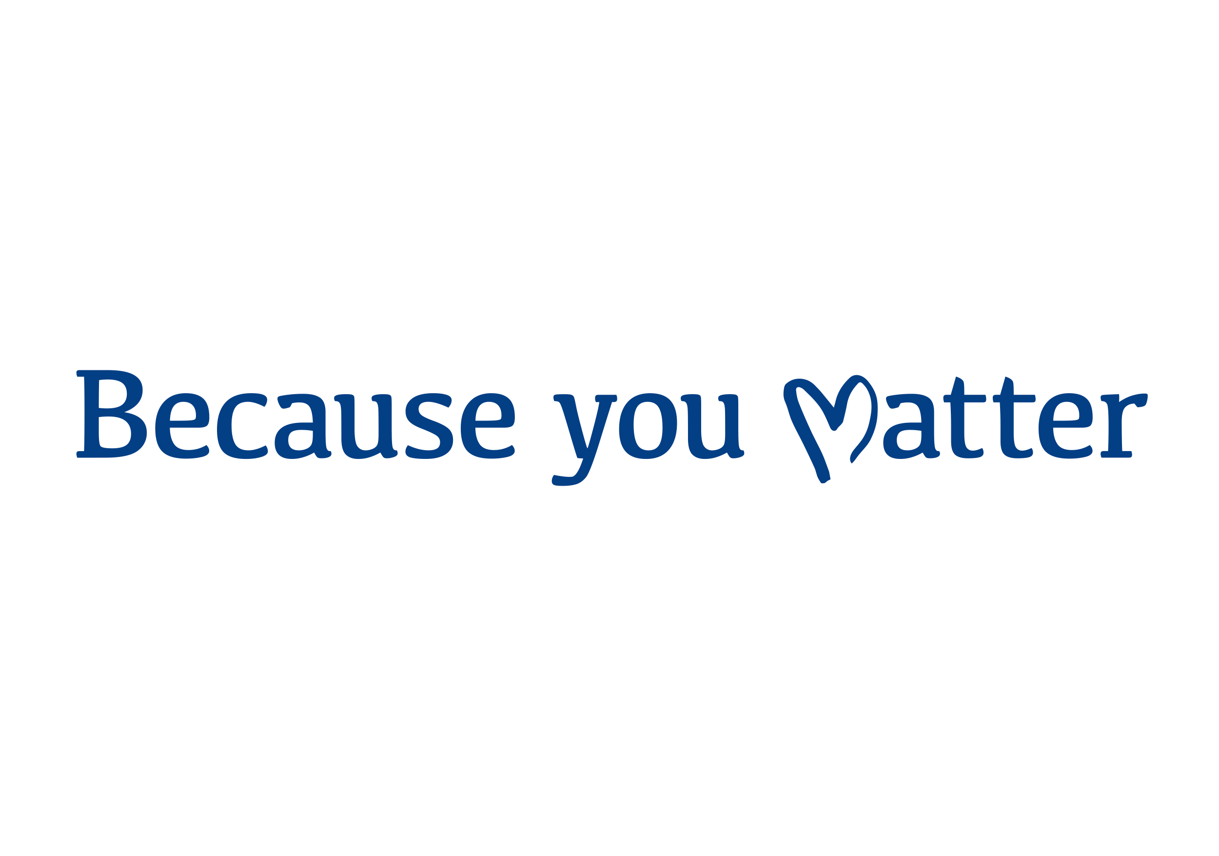

Written Communications Copy: Conversation 2 - January 2024

Longform Copy – 513 words
Uses: Anywhere that requires longer text e.g. blog articles, press releases, newsletters etc.
The Because you Matter Conversations

Thank you to contributing to the Because you Matter Conversations so far.

You told us that our values are the right ones to build a better tomorrow. However, you told us they aren’t always lived and upheld. You asked for clarity about the expectations we should have on each other. So, we’ve prepared behaviours that work with our values that we want you to check and challenge to make sure we heard you properly.

You also told us that there are some barriers to feeling valued and being able to do your best at work today. So, we are looking into how to carry forward action together that will address your more immediate needs where it is possible.

Most of you were focused on today’s challenges. So, we want to give you another chance to tell us about the opportunities we have to improve patient care and staff experience, now and for our future, so that your voice is included in our plans.

How does the second Conversation work?

We held the first Conversation from 10 - 27 October, and now we are opening a second Conversation that will run from 16 January – 30 January. You are invited to:

- Check and challenge the behaviours we drafted using your contributions from the last conversation.
- Tell us more about the opportunities we have to improve patient care and staff experience for our future plans, including our digital clinical system and our new hospital programme.

The Conversation is:

- Anonymous – your name is not attached to anything you share
- For all staff and volunteers at MCHT
- Available 24 hours a day, 7 days a week while the Conversation is live
- Accessible from wherever you may be, on any computer, tablet or smartphone
- Analysed independently, so you can feel safe to share how you really feel

What happens with what is said?
Clever Together, our independent partner, will analyse everything that was shared and report back on updated version of our behaviours and opportunities for our future.

After that we will take the steps to embed the behaviours in our ways of working. That way, we will live our values in everything we do for each other and our patients.

We’ll also use your ideas for our future to help shape our plans so we can improve patient care and staff experience.

Why are we doing this?

The Because you Matter Conversations are an opportunity to share in a safe environment with the promise that your contributions will be heard, recognised and actioned.

By working together to understand the culture and future we want, we can all have a voice and role to play in creating a better tomorrow for ourselves and our patients.

How do I get involved?

Staff: You will receive an email invitation with your login details when the Conversation launches on 16 January. If you took part in the first Conversation, your login details will be the same.

Volunteers and Lead Employer Trainee Junior Doctors: If you haven’t already, register now at becauseyoumatter.clevertogether.com/en/sign-up

We want to hear your voice!

Shortform Copy – 234 words
Uses: Newsletters, Intranet pages, Website pages, etc.
The Because you Matter Conversations are an opportunity for all staff and volunteers at Mid Cheshire NHS Foundation Trust to discuss our future in an anonymous, safe space.

You are invited to check and challenge the behaviours we drafted using your contributions from the last conversation and tell us more about the opportunities we have to improve patient care and staff experience, now and for our future.

The second Conversation will be live from 16 January – 30 January 2024, and will be accessible 24/7 from any device.

What happens with what is said?

We will take the steps to embed the behaviours in our ways of working – from recruitment to retirement.

We’ll also use your ideas for our future to help shape our plans so we can improve patient care and staff experience.

Why are we doing this?

We want to give you the opportunity to share your views.

The Because you Matter Conversations are an opportunity to share in a safe environment with the promise that your contributions will be heard, recognised and actioned.

How do I get involved?

Staff: You will receive an email invitation with your login details when the Conversation launches on 16 January. If you took part in the first Conversation, your login details will remain the same.

Volunteers and Lead Employer Trainee Junior Doctors: If you haven’t already, register now at becauseyoumatter.clevertogether.com/en/sign-up

We want to hear your voice!

